Day 6
Task 1:
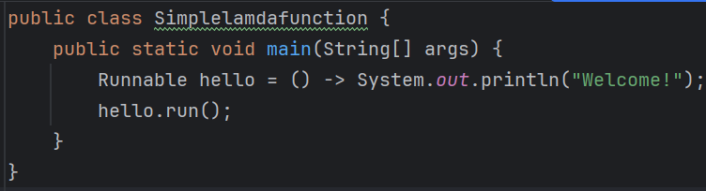
Task 3:
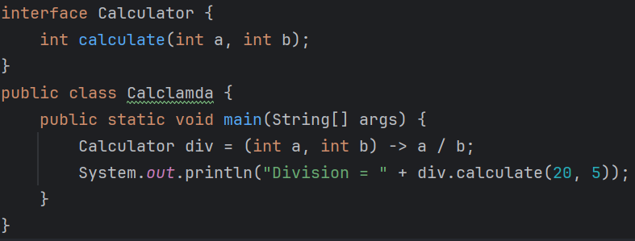
Task 4:
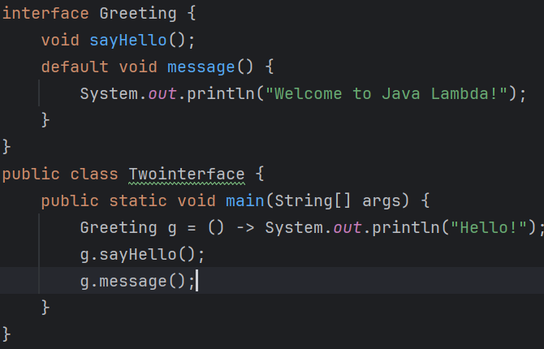

Task 5:
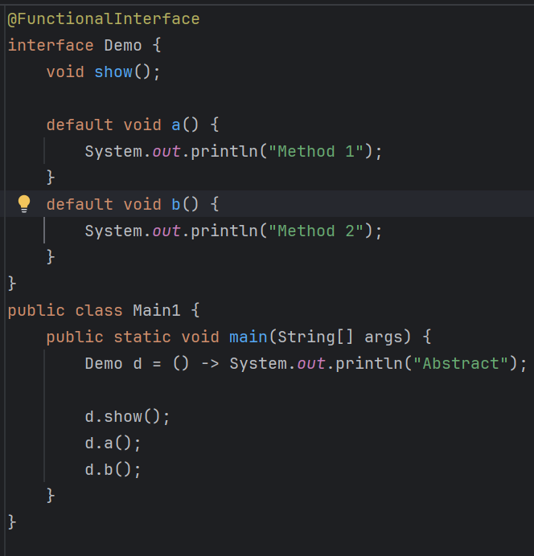
Task 6:
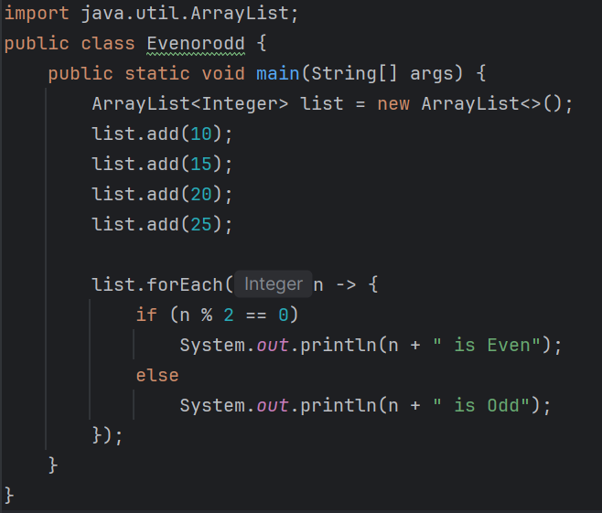
Task 7:
JUnit 5 is a popular Java testing framework used to write and run unit tests for Java applications. It helps developers verify that individual parts of a program work correctly.
Task 8:
@Test, @BeforeAll, @AfterAll, @BeforeEach, @AfterEach etc…....

Task 9:
- JUnit 4 – Older testing framework, Used in legacy projects
- Junit 5 – Modern framework with upgraded features, Java 8 supported can be used for new projects.
Task 10:
JUnit Test Suite is a way to group multiple test classes and run them together as a single unit.
Task 11:
JUnit Vintage is a module of JUnit 5 that allows you to run JUnit 3 and JUnit 4 tests on the JUnit 5 platform.
Test 12:
A mock object is a fake object used in unit testing to simulate the behaviour of a real object.
Task 13:
Mockito is a popular Java mocking framework used for creating and managing mock objects in unit testing.
Task 14:
A Functional Interface is an interface that contains exactly one abstract method. It can have any number of default and static methods.
Task 15:
Before Java 8, interfaces could contain only abstract methods. Java 8 introduced default and static methods to allow methods with implementations inside interfaces.
Task 16:
Stream API is a feature introduced in Java 8 that is used to process collections of data in a functional programming style.
Task 17:
Optional is a class introduced in Java 8 that is used to handle null values safely and avoid Null Pointer Exception.
Task 18:
Variable type is String, but method reference expects a user object.
Task 19:
:: operator Used to refer an existing method without calling it directly. Mainly user in Lamda functions and functional interfaces.
Task 20:
That allows you to refer to an existing method using the :: (double colon) operator instead of writing a lambda expression.

